1-History

What Is History in Version Control?
# Source: AI Source: Provided by: [Data Path: Persons Table -> ID Column: 1, Name_En Column: Motasem Essam] -> From: [ChatGPT] on [2/15/2026]
In Git, history is the record of all commits made in a repository. It’s basically a timeline of every change your project has gone through, stored as snapshots.

Key points
# Source: AI Source: Provided by: [Data Path: Persons Table -> ID Column: 1, Name_En Column: Motasem Essam] -> From: [ChatGPT] on [2/15/2026]
- Each commit is a point in history
  - Commits include:
    - Snapshot of files
    - Commit message
    - Author info
    - Timestamp
    - Parent commit(s)
- History is connected
  - Each commit points to its parent commit, forming a chain.
  - This allows you to go back in time, see changes, or restore previous versions.
- Initial commit starts the history
  - First commit → no parent → beginning of the timeline

Why history is important
# Source: AI Source: Provided by: [Data Path: Persons Table -> ID Column: 1, Name_En Column: Motasem Essam] -> From: [ChatGPT] on [2/15/2026]
- Track who changed what and when
- Compare different versions of files
- Undo mistakes → git checkout, git revert, git reset
- Understand project evolution over time

Example
# Source: AI Source: Provided by: [Data Path: Persons Table -> ID Column: 1, Name_En Column: Motasem Essam] -> From: [ChatGPT] on [2/15/2026]
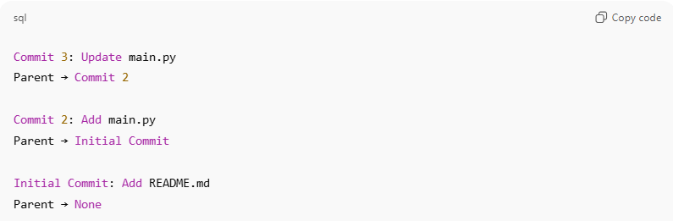
Commit 3: Update main.py
Parent → Commit 2

Commit 2: Add main.py
Parent → Initial Commit

Initial Commit: Add README.md
Parent → None
- This chain of commits is the history of your project.

Commands to view history
# Source: AI Source: Provided by: [Data Path: Persons Table -> ID Column: 1, Name_En Column: Motasem Essam] -> From: [ChatGPT] on [2/15/2026]
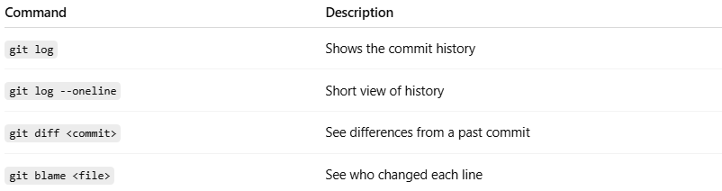
Command | Description
git log | Shows the commit history
git log --oneline | Short view of history
git diff <commit> | See differences from a past commit
git blame <file> | See who changed each line

💡 Memory trick:
# Source: AI Source: Provided by: [Data Path: Persons Table -> ID Column: 1, Name_En Column: Motasem Essam] -> From: [ChatGPT] on [2/15/2026]
History = the chain of all commits (snapshots) from the initial commit to the latest commit

2-Branch History

What Is Branch History in Version Control?
# Source: AI Source: Provided by: [Data Path: Persons Table -> ID Column: 1, Name_En Column: Motasem Essam] -> From: [ChatGPT] on [2/15/2026]
Branch History = the list of commits in that branch, in the order they were made.
It’s basically:
“Everything that happened on this branch, step by step, from the first commit to the latest commit (HEAD).”
Example:
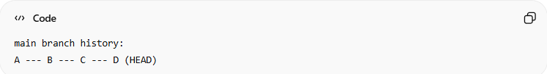
main branch history:
A --- B --- C --- D (HEAD)
- A → first commit
- B → second commit
- C → third commit
- D → latest commit (HEAD)
The history shows all the commits in order.

Why it’s useful
# Source: AI Source: Provided by: [Data Path: Persons Table -> ID Column: 1, Name_En Column: Motasem Essam] -> From: [ChatGPT] on [2/15/2026]
- Lets you see all changes made in the branch.
- Helps with reverting mistakes or understanding what happened.
- Necessary for operations like rebase, cherry-pick, or reset, because Git needs to know the sequence of commits.

Visual analogy
# Source: AI Source: Provided by: [Data Path: Persons Table -> ID Column: 1, Name_En Column: Motasem Essam] -> From: [ChatGPT] on [2/15/2026]
Think of a branch like a timeline or path in your project:
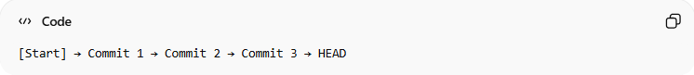
[Start] → Commit 1 → Commit 2 → Commit 3 → HEAD
The history is the full path from start to HEAD.

✅ Simple definition:
# Source: AI Source: Provided by: [Data Path: Persons Table -> ID Column: 1, Name_En Column: Motasem Essam] -> From: [ChatGPT] on [2/15/2026]
Branch history = the sequence of commits that have been made on a branch, showing all changes from the first commit to the current one.

